Scalene Obtuse Triangle
# Source: AI Source: Provided by: [Data Path: Persons Table -> ID Column: 1, Name_En Column: Motasem Essam] -> From: [ChatGPT] on [7/25/2026]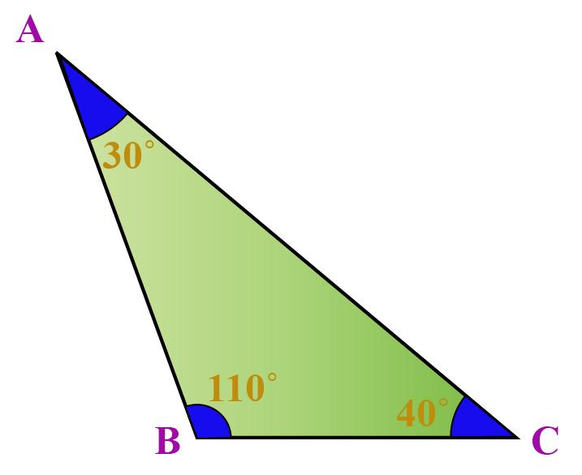
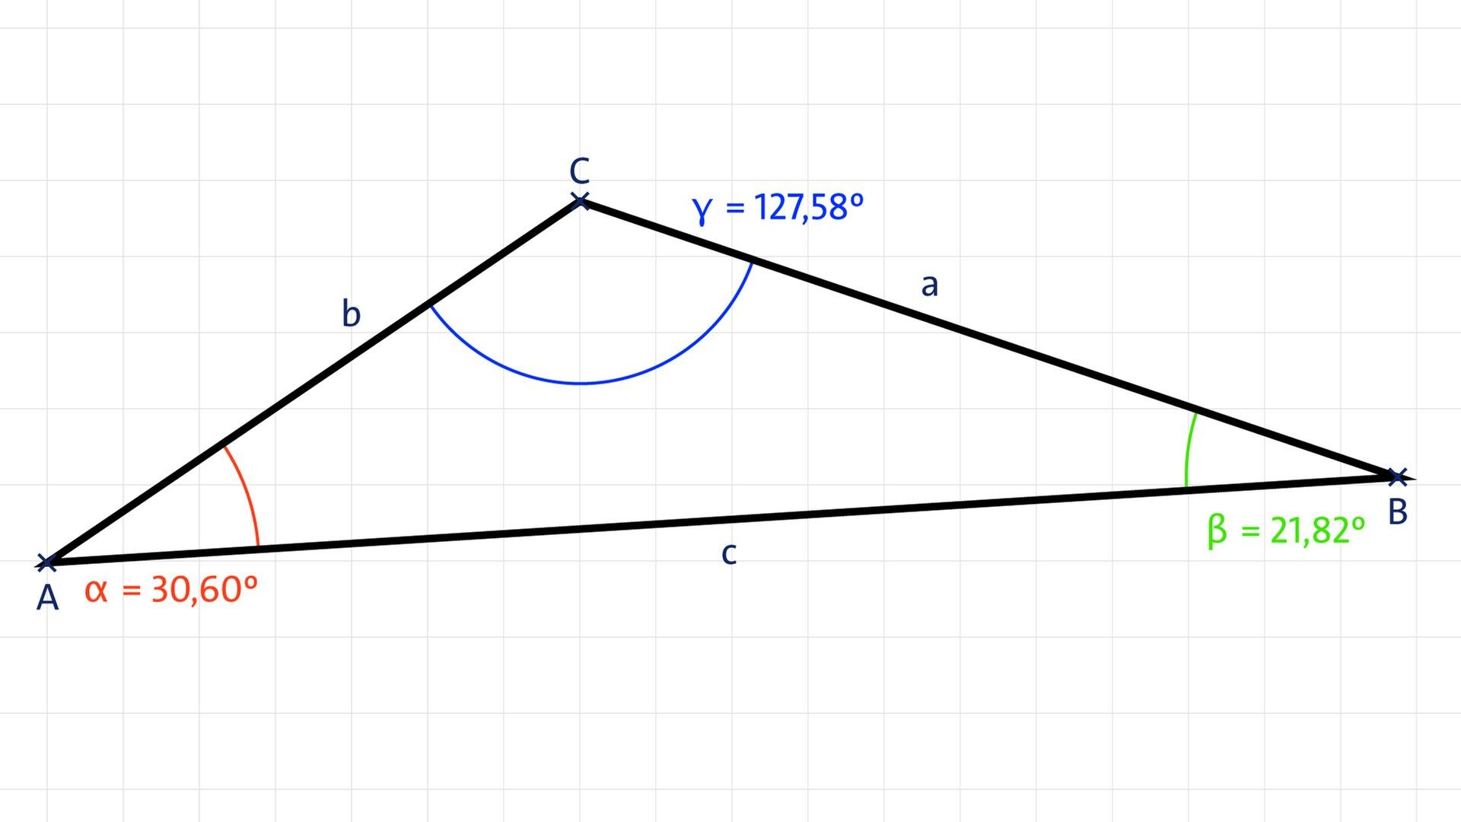
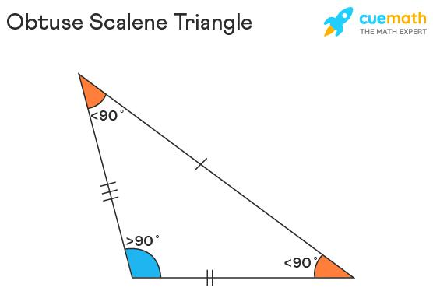

Definition
# Source: AI Source: Provided by: [Data Path: Persons Table -> ID Column: 1, Name_En Column: Motasem Essam] -> From: [ChatGPT] on [7/25/2026]
A Scalene Obtuse Triangle is a triangle that has:
- Three unequal sides, and
- Exactly one obtuse interior angle, measuring more than ${90}^{∘}$and less than ${180}^{∘}$.
Therefore:
$$\boxed{AB≠BC≠CA}$$
and exactly one angle satisfies:
$$\boxed{{90}^{∘}<∠A<{180}^{∘}}$$
The other two angles are acute.

Classification
# Source: AI Source: Provided by: [Data Path: Persons Table -> ID Column: 1, Name_En Column: Motasem Essam] -> From: [ChatGPT] on [7/25/2026]
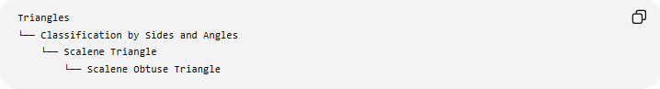
Triangles
└── Classification by Sides and Angles
└── Scalene Triangle
└── Scalene Obtuse Triangle
Or through the two independent classifications:
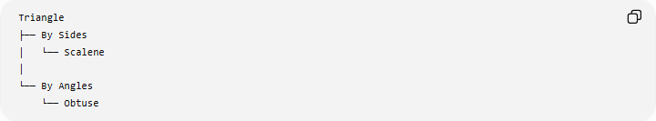
Triangle
├── By Sides
│ └── Scalene
│
└── By Angles
└── Obtuse
Thus:
$$\boxed{\text{Scalene Obtuse Triangle}=\text{Scalene by sides}+\text{Obtuse by angles}}$$

Fundamental Properties
# Source: AI Source: Provided by: [Data Path: Persons Table -> ID Column: 1, Name_En Column: Motasem Essam] -> From: [ChatGPT] on [7/25/2026]
Consider $△ABC$, where $∠C$is the obtuse angle.
Then:
$$\boxed{{90}^{∘}<∠C<{180}^{∘}}$$
while:
$$\boxed{∠A<{90}^{∘}, ∠B<{90}^{∘}}$$
Because the triangle is scalene:
$$\boxed{∠A≠∠B≠∠C}$$
and:
$$\boxed{AB≠BC≠CA}$$
The side opposite the obtuse angle is the longest side.
Therefore, if $C$is the obtuse angle:
$$\boxed{AB>BC}$$
and
$$\boxed{AB>AC}$$

Angle Structure
# Source: AI Source: Provided by: [Data Path: Persons Table -> ID Column: 1, Name_En Column: Motasem Essam] -> From: [ChatGPT] on [7/25/2026]
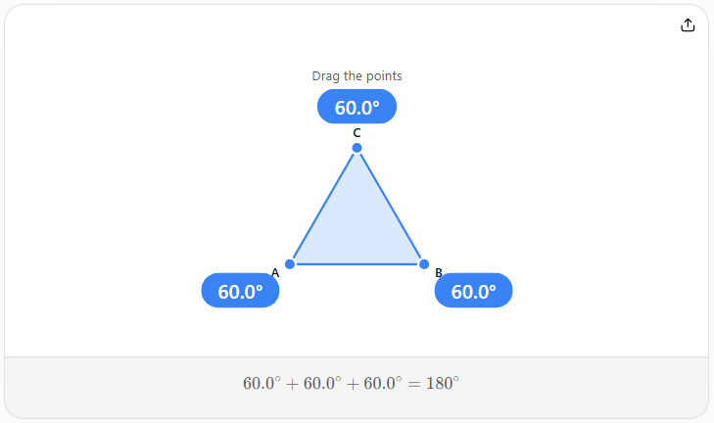
The three interior angles satisfy:
$$\boxed{∠A+∠B+∠C={180}^{∘}}$$
For an obtuse triangle:
$$\boxed{∠C>{90}^{∘}}$$
Therefore:
$$\boxed{∠A+∠B<{90}^{∘}}$$
The two acute angles are different because the triangle is scalene.
Example
$$\boxed{{30}^{∘}+{50}^{∘}+{100}^{∘}={180}^{∘}}$$
This represents a scalene obtuse triangle because all three angles are different and one is greater than ${90}^{∘}$.

Side-Length Test
# Source: AI Source: Provided by: [Data Path: Persons Table -> ID Column: 1, Name_En Column: Motasem Essam] -> From: [ChatGPT] on [7/25/2026]
Let $c$be the longest side.
A triangle is obtuse when:
$$\boxed{c^{2}>a^{2}+b^{2}}$$
For a scalene obtuse triangle, we additionally require:
$$\boxed{a≠b≠c}$$
Thus:
$$\boxed{c^{2}>a^{2}+b^{2} \text{and} a,b,c\text{ are all different}}$$
This is the converse of the Pythagorean theorem applied to the longest side.

Comparison of the Three Triangle Types
# Source: AI Source: Provided by: [Data Path: Persons Table -> ID Column: 1, Name_En Column: Motasem Essam] -> From: [ChatGPT] on [7/25/2026]
For a triangle with longest side $c$:
$$\boxed{c^{2}<a^{2}+b^{2}} ⇒ \text{Acute} \\ \boxed{c^{2}=a^{2}+b^{2}} ⇒ \text{Right} \\ \boxed{c^{2}>a^{2}+b^{2}} ⇒ \text{Obtuse}$$
Therefore, a scalene triangle can be classified as scalene acute, scalene right, or scalene obtuse.

Example
# Source: AI Source: Provided by: [Data Path: Persons Table -> ID Column: 1, Name_En Column: Motasem Essam] -> From: [ChatGPT] on [7/25/2026]
Consider side lengths:
$$\boxed{3, 4, 6}$$
Step 1 — Check the sides
$$3≠4, 4≠6, 3≠6$$
So the triangle is scalene.
Step 2 — Check the triangle inequality
$$3+4>6 \\ 7>6$$
Therefore, these lengths can form a triangle.
Step 3 — Test the longest side
The longest side is $6$.
$$6^{2}=36$$
while:
$$3^{2}+4^{2}=9+16=25$$
Since:
$$\boxed{36>25}$$
the triangle is obtuse.
Therefore:
$$\boxed{3, 4, 6\text{ is a scalene obtuse triangle}}$$
Its angles are approximately:
$$\boxed{{28.96}^{∘}, {41.41}^{∘}, {109.63}^{∘}}$$

Altitudes
# Source: AI Source: Provided by: [Data Path: Persons Table -> ID Column: 1, Name_En Column: Motasem Essam] -> From: [ChatGPT] on [7/25/2026]
A scalene obtuse triangle has three altitudes.
However, because the triangle is obtuse, some altitude segments lie outside the triangle.
For example, if $C$is the obtuse vertex, the altitude from $A$to the line $BC$may meet the extension of $BC$rather than the segment $BC$.
This is an important difference from an acute triangle, where all three altitude feet lie on the sides.

Orthocenter
# Source: AI Source: Provided by: [Data Path: Persons Table -> ID Column: 1, Name_En Column: Motasem Essam] -> From: [ChatGPT] on [7/25/2026]
The three extended altitudes intersect at the orthocenter $H$.
For an obtuse triangle:
$$\boxed{H\text{ lies outside the triangle}}$$
This contrasts with an acute triangle, whose orthocenter is inside.

Circumcenter
# Source: AI Source: Provided by: [Data Path: Persons Table -> ID Column: 1, Name_En Column: Motasem Essam] -> From: [ChatGPT] on [7/25/2026]
The perpendicular bisectors of the three sides meet at the circumcenter $O$.
For an obtuse triangle:
$$\boxed{O\text{ lies outside the triangle}}$$
Therefore, both the circumcenter and orthocenter are outside:
$$\boxed{O,H\text{ are outside}}$$

Centroid and Incenter
# Source: AI Source: Provided by: [Data Path: Persons Table -> ID Column: 1, Name_En Column: Motasem Essam] -> From: [ChatGPT] on [7/25/2026]
The centroid $G$is the intersection of the three medians.
$$\boxed{G\text{ lies inside}}$$
The incenter $I$is the intersection of the three internal angle bisectors.
$$\boxed{I\text{ lies inside}}$$
Therefore:
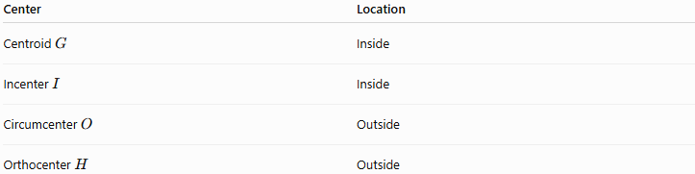
Center | Location
Centroid $G$ | Inside
Incenter $I$ | Inside
Circumcenter $O$ | Outside
Orthocenter $H$ | Outside

Euler Line
# Source: AI Source: Provided by: [Data Path: Persons Table -> ID Column: 1, Name_En Column: Motasem Essam] -> From: [ChatGPT] on [7/25/2026]
For a scalene triangle:
$$\boxed{O, G, H\text{ are collinear}}$$
The standard Euler-line relationship is:
$$\boxed{OG:GH=1:2}$$
or:
$$\boxed{GH=2OG}$$
and:
$$\boxed{OH=3OG}$$
Although $O$and $H$are outside the triangle in the obtuse case, the Euler line still exists.
The incenter $I$generally does not lie on the Euler line.

Symmetry
# Source: AI Source: Provided by: [Data Path: Persons Table -> ID Column: 1, Name_En Column: Motasem Essam] -> From: [ChatGPT] on [7/25/2026]
A scalene triangle has no equal sides.
Therefore:
$$\boxed{\text{Number of lines of symmetry}=0}$$
It also has no nontrivial rotational symmetry.
This distinguishes it from an isosceles obtuse triangle, which has one line of symmetry.

Area
# Source: AI Source: Provided by: [Data Path: Persons Table -> ID Column: 1, Name_En Column: Motasem Essam] -> From: [ChatGPT] on [7/25/2026]
The standard area formula is:
$$\boxed{A=\frac{1}{2}bh}$$
However, for an obtuse triangle, the altitude corresponding to a particular side may meet the extension of that side.
Using two sides and their included angle:
$$\boxed{A=\frac{1}{2}ab\sin{C}}$$
where $C$is the included obtuse angle.
Since:
$${90}^{∘}<C<{180}^{∘}$$
we still have:
$$\sin{C}>0$$
so the area remains positive.

Heron's Formula
# Source: AI Source: Provided by: [Data Path: Persons Table -> ID Column: 1, Name_En Column: Motasem Essam] -> From: [ChatGPT] on [7/25/2026]
For side lengths $a,b,c$:
$$s=\frac{a+b+c}{2}$$
Then:
$$\boxed{A=\sqrt{s\left(s-a\right)\left(s-b\right)\left(s-c\right)}}$$
For the example $3,4,6$:
$$s=\frac{3+4+6}{2}=\frac{13}{2}$$
and:
$$A=\sqrt{\frac{13}{2}\frac{7}{2}\frac{5}{2}\frac{1}{2}} \\ \boxed{A=\frac{\sqrt{455}}{4}≈5.33}$$

Comparison with Other Scalene Triangles
# Source: AI Source: Provided by: [Data Path: Persons Table -> ID Column: 1, Name_En Column: Motasem Essam] -> From: [ChatGPT] on [7/25/2026]
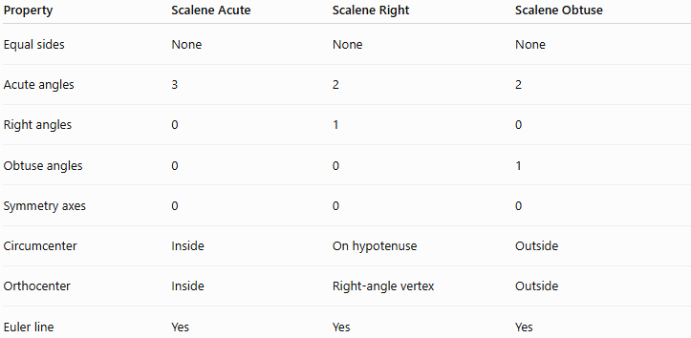
Property | Scalene Acute | Scalene Right | Scalene Obtuse
Equal sides | None | None | None
Acute angles | 3 | 2 | 2
Right angles | 0 | 1 | 0
Obtuse angles | 0 | 0 | 1
Symmetry axes | 0 | 0 | 0
Circumcenter | Inside | On hypotenuse | Outside
Orthocenter | Inside | Right-angle vertex | Outside
Euler line | Yes | Yes | Yes

Comparison with Isosceles Obtuse Triangle
# Source: AI Source: Provided by: [Data Path: Persons Table -> ID Column: 1, Name_En Column: Motasem Essam] -> From: [ChatGPT] on [7/25/2026]
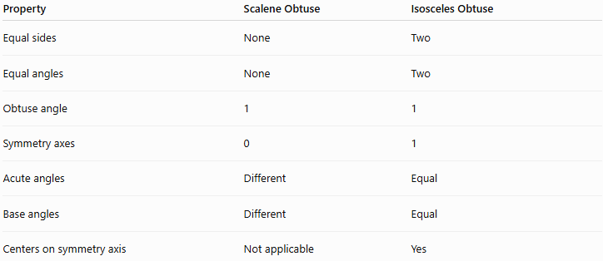
Property | Scalene Obtuse | Isosceles Obtuse
Equal sides | None | Two
Equal angles | None | Two
Obtuse angle | 1 | 1
Symmetry axes | 0 | 1
Acute angles | Different | Equal
Base angles | Different | Equal
Centers on symmetry axis | Not applicable | Yes
For example:
$$\boxed{3,4,6}$$
is scalene obtuse, while:
$$\boxed{5,5,8}$$
is isosceles obtuse.

Real-World Applications
# Source: AI Source: Provided by: [Data Path: Persons Table -> ID Column: 1, Name_En Column: Motasem Essam] -> From: [ChatGPT] on [7/25/2026]
Scalene obtuse triangles can appear in:
- Irregular land surveying
- Architectural layouts
- Structural engineering
- Geographic mapping
- Computer graphics
- Triangulation
- Navigation
- Irregular triangular components
- Coordinate geometry
They are useful for representing triangular configurations where the longest side is sufficiently large relative to the other two sides to create an obtuse angle.

Key Points
# Source: AI Source: Provided by: [Data Path: Persons Table -> ID Column: 1, Name_En Column: Motasem Essam] -> From: [ChatGPT] on [7/25/2026]
- A Scalene Obtuse Triangle has three unequal sides.
- It has one obtuse angle.
- Its other two angles are acute and unequal.
- The obtuse angle is opposite the longest side.
- If $c$is the longest side:
$$\boxed{c^{2}>a^{2}+b^{2}}$$
- It has no line of symmetry.
- Its centroid and incenter are inside.
- Its circumcenter and orthocenter are outside.
- Its Euler line contains $O$, $G$, and $H$.
- Its altitudes may intersect extensions of the sides.
- It can be analyzed using the Law of Cosines, Law of Sines, and Heron's Formula.

Conclusion
# Source: AI Source: Provided by: [Data Path: Persons Table -> ID Column: 1, Name_En Column: Motasem Essam] -> From: [ChatGPT] on [7/25/2026]
A Scalene Obtuse Triangle combines the classifications scalene by sides and obtuse by angles. It has three unequal sides and three unequal angles, with exactly one angle greater than ${90}^{∘}$. Its longest side is opposite the obtuse angle, while its circumcenter and orthocenter lie outside the triangle.
Would you like a simple labeled diagram or a comparison with a scalene acute triangle?

